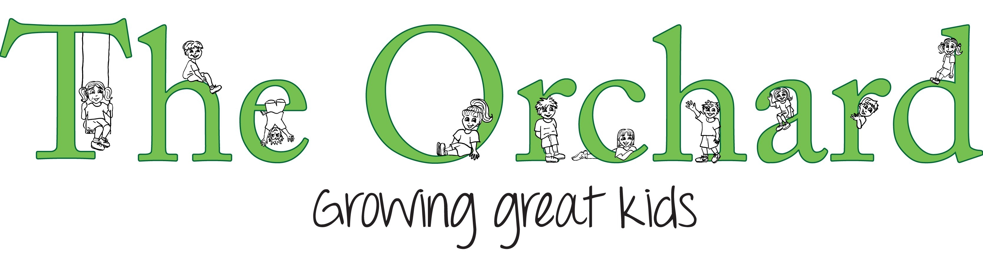
Child Protection Policy & Guidance
August 2026

Policy summary
This policy outlines our commitment to child protection. It includes our protocols when child abuse is reported to us or suspected by us. It also includes practice notes on measures to be taken to prevent child abuse. Staff are expected to be familiar with this policy and abide by it.

Purpose statement
We have an obligation to ensure the wellbeing of children in our care and are committed to the prevention of child abuse and neglect and to the protection of all children. The safety and wellbeing of the child is our top priority when investigating suspected or alleged abuse.
We support the roles of the New Zealand Police and Oranga Tamariki (formerly Child, Youth and Family) in the investigation of suspected abuse and will report suspected/alleged abuse to these agencies.
We support families/whānau to protect their children.
We provide a safe environment, free from physical, emotional, verbal or sexual abuse.

Policy principles
- The interest and protection of the child is paramount in all actions.
- We recognise the rights of family/whānau to participate in the decision-making about their children.
- We have a commitment to ensure that all staff are able to identify the signs and symptoms of potential abuse and neglect and are able to take appropriate action in response.
- We are committed to supporting all staff to work in accordance with this policy, to work with partner agencies and organisations to ensure our approach to child protection is consistent and high quality.
- We will always comply with relevant legislative responsibilities.
- We are committed to share information in a timely way and to discuss any concerns about an individual child with colleagues or the Person in Charge.
- We are committed to promote a culture where staff feel confident that they can constructively challenge poor practice or raise issues of concern without fear of reprisal.
- We adhere to the requirements of the Protected Disclosure act (2000). Details of our procedure may be found in our Whistle Blowing policy.
- This policy will be reviewed at least every year.

Identifying possible abuse or neglect
Child Abuse is defined in the Children Young Persons and their Families Act as “the harming (whether physically, emotionally, or sexually), ill-treatment, abuse, neglect or deprivation of any child or young person.”

Emotional Abuse
Emotional abuse occurs when a child’s emotional, psychological or social well-being and sense of worth is continually battered. This includes confinement, isolation, verbal assault, humiliation, intimidation, infantilisation, or any other treatment that may diminish the sense of identity, dignity, and self-worth. We also include exposure to Family Violence in this category.

Neglect
Neglect is a pattern of behaviour that occurs over a period of time and results in impaired functioning/development. It is a failure to provide for a child’s basic needs.

Physical Abuse
Physical abuse can be caused from smacking, punching, beating, kicking, shaking, biting, burning or throwing the child. Physical abuse may also result from excessive or inappropriate discipline or violence within the family and wider network and is considered abuse regardless of whether or not it was intended to hurt the child. Physical abuse may be the result of a single episode or of a series of episodes.

Sexual Abuse
Sexual abuse includes acts or behaviours where an adult, older or more powerful person uses a child for a sexual purpose. There are 2 different types of child sexual abuse. These are called contact abuse and non-contact abuse.
- Contact abuse involves touching activities where an abuser makes physical contact with a child, including penetration. It includes: sexual touching of any part of the body whether the child's wearing clothes or not; rape or penetration by putting an object or body part inside a child's mouth, vagina or anus; forcing or encouraging a child to take part in sexual activity; making a child take their clothes off, touch someone else's genitals or masturbate.
- Non-contact abuse involves non-touching activities, such as grooming, exploitation, persuading children to perform sexual acts over the internet and flashing. It includes: encouraging a child to watch or hear sexual acts; not taking proper measures to prevent a child being exposed to sexual activities by others; meeting a child following sexual grooming with the intent of abusing them; online abuse including making, viewing or distributing child abuse images; allowing someone else to make, view or distribute child abuse images; showing pornography to a child; sexually exploiting a child for money, power or status (child exploitation).
Staff should become familiar with the possible physical and behavior clues to child abuse listed on pages 16-18. In addition, a copy of ‘Signs of abuse and neglect’ chart (CYF) can be found on page 20 of this document along with a list of further training resources on page 15.

Responding to suspected abuse or neglect
It is essential to continue to maintain a confidential record, including observations of the child’s behaviour for some time following an allegation or incident. The process for responding to child abuse is given in the ‘Reporting Process Flowchart’ on page 19 of this document.
An incident report template is also provided on page 21 of this document.
All suspicions or observed incidents or reports of incidents should be reported directly to the Person in Charge as soon as possible, who will immediately take steps to protect the child(ren) and record the report.
If there is clear evidence or reasonable cause to believe an instance of child abuse has taken place, the Person in Charge shall notify Oranga Tamariki: 0508 326 459.
In addition to guiding staff to make referrals of suspected child abuse and neglect to the statutory agencies (i.e., Oranga Tamariki or the Police), this child protection policy will also help staff to identify and respond to the needs of the many vulnerable children whose wellbeing is of concern. In many of these cases the involvement of statutory agencies would be inappropriate and potentially harmful to families/whānau. Throughout New Zealand statutory and non-statutory agencies provide a network of mutually supportive services and it is important for our organisation to work with these to respond to the needs of vulnerable children and families/whānau in a manner proportionate to the level of need and risk. Where there is a serious injury or illness or incident involving a child while at the service that is required to be notified to a specified agency, the service provider must also notify the Ministry of Education at the same time.

Staff members will discuss suspicions with a senior staff member. Where appropriate, the person making the allegation will be given a copy of this policy.

Immediate response to suspicion of child abuse

Ongoing care for vulnerable children
Ensure the child's immediate safety - do not alert the suspected abuser.
- If a child tells of abuse; listen; don't question them.
- Say you're glad they told you and you're sorry it happened
- Let them know it's not their fault and that you'll do your best to help
- Do not ask further questions
- Do not put words in the child's mouth
- Allow them to tell only as much as they want
- Continue to support the child
- Ignore negative behaviour
If a child's behaviour affects other children's health and well being at the Centre, a parent meeting will be called by the Owner or Senior staff member, to discuss the situation. The final decision of future action will be made by Management (or person appointed if management is away) and the Child Safety Team, with consideration to the fact that the Senior staff member has the right to exclude any child if his/her behaviour poses a significant danger to others.

The Basic Principles for Responding to Suspected Child Abuse
- Believe what children tell you and what you see.
- Always take action in the short term to ensure the immediate safety of the child. This may mean contacting the Oranga Tamariki service or the police if you think there is an immediate risk of the child being abused again.
- Immediately record clear concerns and observations, factual statements with dates
- We recommend that you do not make decisions alone. Consult with someone experienced. If there is no short-term risk, take time to consult thoroughly in order to make a well-informed decision.
- Act on your concerns. Don’t leave it to someone else or hope it won’t happen again. If you have told the person you believe is responsible for taking action and they do not act, take further action yourself.
- Seek support for yourself. The tasks and situation will be stressful.
- Where abuse may have been perpetrated by a family member or someone close to the family, do not initially inform the family, but ensure that the appropriate person informs them at the appropriate time under guidance from Oranga Tamariki.

Allegations or concerns about staff
Protected Disclosure: we will observe the requirements of the Protected Disclosure Act 2000 in dealing with concerns raised by a staff member concerning another staff member. Our Whistle Blowing policy outlines the procedures that will be followed.
When there are suspicions or allegations of abuse by a staff member, the person responsible for Child Protection must immediately ensure that the suspected individual does not have any contact with the child making the allegation. A risk assessment must be undertaken to determine what level of access, if any, that person should have to other children. The suspected staff member (or volunteer) will be prevented from having further unsupervised access to children during any investigation and will be informed fully of their rights. To ensure the child and staff member are kept safe, management may take steps to remove the staff member against whom an allegation has been made from the environment.
The person managing the child abuse issue will not be the same person as that managing the employment issue. If there is a need to pursue an allegation as an employer, consult with Oranga Tamariki or the Police before advising the person concerned. Inform the suspected person that they have a right to seek legal advice and providing them with an opportunity to respond. They should also be informed of their right to seek support from the relevant union/representative body. It is vital to follow ordinary disciplinary policies, guided by the employment contract and relevant statutory obligations.
If there is insufficient evidence to pursue a criminal prosecution, then a disciplinary investigation may still be undertaken if there is "reasonable cause to suspect" that abuse may have occurred. The allegation may represent inappropriate behaviour or poor practice by a member of staff which needs to be considered under internal disciplinary procedures.
We recognise the added stress to fellow staff in such situations and will ensure support is available.
We commit not to use ‘settlement agreements’, where these are contrary to a strong culture of child protection. Some settlement agreements allow a member of staff to agree to resign provided that no disciplinary action is taken, and a future reference is agreed. Where the conduct at issue concerned the safety or wellbeing of a child, use of such agreements is contrary to a culture of child protection.
Under the Education Act, employers must make a mandatory report to the Education Council in certain circumstances. Failing to make a report is an offence, which carries a fine of up to $25,000 unless there is reasonable justification.

Ill-treatment of children
Where we have reasonable grounds to believe that a person employed or engaged in the service, or any other person, has physically ill-treated or abused a child or committed a crime against children, or in guiding or controlling a child has subjected the child to solitary confinement, immobilisation, or deprivation of food, drink, warmth, shelter, or protection, we will take steps to ensure that the person is excluded from coming into contact with the children participating in the service (Reg. 56).
Where the manager or owner is satisfied that it is necessary to do so to ensure that no child is ill-treated, we will ensure that the person is excluded from the service and does not enter or remain in any premises where the service is provided while it is being provided.

WHEN TO MAKE A MANDATORY REPORT
Employers must IMMEDIATELY report to the Council when:
- a teacher is dismissed for any reason
- a teacher resigns from a teaching position, if within the 12 months preceding the resignation the employer advised the teacher it was dissatisfied with, or intended to investigate, any aspect of the teacher’s conduct or competence, or on the expiry of the teacher's fixed-term contract
- a teacher ceases to be employed by the employer, and within the following 12 months the employer receives a complaint about the teacher's conduct or competence while he or she was an employee
- the employer has reason to believe the teacher has engaged in serious misconduct
- the employer is satisfied that, despite completing competence procedures with the teacher, the teacher has not reached the required competence level.

Confidentiality and information sharing
The Privacy Act 2020 and the Children, Young Persons, and their Families Act 1989 allow information to be shared to keep children safe when abuse or suspected abuse is reported or investigated. Note that under sections 15 and 16 of the CYPF Act, any person who believes that a child has been, or is likely to be, harmed physically, emotionally or sexually or ill-treated, abused, neglected or deprived may report the matter to Oranga Tamariki or the Police and, provided the report is made in good faith, no civil, criminal or disciplinary proceedings may be brought against them.

Recruitment and employment (safety checking)
Our prime consideration in employing staff is ensuring they have the skills and attributes which contribute to the children’s well being.
Safety checking will be carried out in accordance with the Children’s Act 2014. This will include: 1) identity confirmation, 2) records search, 3) teacher registration check (if applicable), 4) Previous criminal conviction (Police Vet), 5) work history, 6) referees checked (at least one), 7) interview (either in person or via zoom). This information forms the basis for a risk assessment where management will consider the applicants suitability. If there is any suspicion that an applicant might pose a risk to a child, that applicant will not be employed.
Where we suspect that a worker or another person at the Centre has perpetrated child abuse, we will report the matter promptly to management and statutory authorities. Staff members under suspicion will be suspended on full pay while the matter is investigated, and they will be informed fully of their rights. Families, whānau, children, staff and others involved in the investigation of the suspected child abuse should have support through organisations in the community, Oranga Tamariki and other agencies.

Training, supervision and support
- Training, resources and/or advice will be available to ensure that all staff can carry out their roles in terms of this policy, particularly:
- Understanding child abuse and indicators of child abuse.
- How to reduce the risk of child abuse.
- Understanding and complying with legal obligations in regard to child abuse.
- Working with outside agencies on child abuse issues.
- Planning of environment and supervision to minimise risk.
- Dealing with child/parents/family/whānau.
- Staff are advised not to babysit privately for centre clients.

This policy will be part of the initial staff induction programme.

Volunteers and Practicum Students
- Volunteers/students will be welcomed into the Centre subject to safety checking
- At no times will a volunteer or student be left alone with a child or be placed on nappy changing duty.
- Where we rely on a TEO to carry out the safety check for students on our behalf, we will obtain a letter from the TEO confirming this. If any components of the safety check have not been completed by the TEO, we are responsible for completing these. We always complete the identity check and risk assessment, even if these have already been completed by the TEO. A separate letter should be obtained for each named student teacher.

Parents/Caregivers/Whānau
- Parents will be involved in the development and review of any child protection policies.
- Parents will be encouraged to spend time in the centre and to participate in daily activities.
- Parents will have access to information regarding a range of support agencies.

Supervision Guidelines
Staff working in the Centre are well supervised and visible in the activities they perform with children.
Parents should perform care-taking tasks only with their own children. Visitors to the Centre should not perform care-taking tasks with children or be alone with them. There is an open door policy for private spaces where intimate care-taking of children is required, e.g. toileting, nappy changing and sleeping.
This Centre has established rules about acceptable touching of children, which are discussed regularly with staff and other adults (Positive Guidance Policy). If a child initiates physical contact in the seeking of affection, reassurance, or comfort it is appropriate to respond. It is not appropriate to force unwanted affection or touching on a child.
Physical contact of children during changing or cleansing must be for the purpose of that task only and no more than is necessary. Encourage children to take care of themselves if possible. In making physical contact with children, staff should be guided by the principal that they would do so only to meet the child’s physical or emotional needs. Touching should never be initiated to gratify adult’s needs. Children should not be asked to take care of adult needs, physical or otherwise. Except in an emergency, children are not taken from the service without parental approval, which is in writing and noted on their enrolment card.

Protection of Staff
This Centre is committed to providing a safe working environment for all our staff and ensure that employee privacy is protected. We take all reasonable steps to ensure staff safety. The centre will not disclose personal information (including personal address, phone numbers and personal circumstances) of any employee, to any child, parent or member of the public. Information will be kept secure in a locked filing cabinet in the office and only employees with specific authority will be permitted access to confidential employee information.
We require staff to be observant. If you have a concern regarding a child (ie observation of an unusual behaviour, evidence of injury etc) then you must document this concern and pass it onto your Supervisor. We recommend that staff report any such observations immediately to the Centre owner who will help them determine the appropriate course of action. We recommend that you don’t act alone. Your written observation/statement will be retained by the centre as confidential information and kept on file for our records.
We recommend that you consult with other team members and the Centre Owner to make a final decision whether it is appropriate to report your observation to an external agency (guidelines previously stated throughout the policy). Your statement/identity will not be revealed by the centre to any third party (except any agencies required to support the centre) and only in consultation with you or as required by law.
For the protection of staff who, through the course of their work, are caring for children's bodily needs the following should be noted. All details of care given in respect to children's genital areas must be recorded with date, time and action taken, as soon as possible after the event. This includes: washing genitals (toileting sheet), applying medication to genitals (medicine form), inspection of genital areas if soreness, itching or injury is suspected (accident book). Teachers are not to be left alone with children where a situation could arise where allegations of sexual abuse could be made.
Never photograph a child’s ano-genital area, even as a record of your concern.

Alcohol/Drugs
The centre has a zero tolerance for staff use of drugs at any time and suspicions will be reported to the Education Council. We have policies in place to ensure that no staff member is under the influence of drugs or alcohol whilst working in the Centre. If any parent arrives to pick up their child whilst suspected to be under the influence of drugs of alcohol, staff will use their discretion to decide whether the child is safe to be driven by the parent. Staff can offer to call another family member to pick up the child if they see fit. Where drivers are not cooperative, staff should call the police.

CHILD SAFETY TEAM
A Child Safety Team of all staff members is responsible for reviewing and implementing the policy of the Centre. Staff members are given initial training in child abuse and are to attend refresher meetings as they become available, or organised by the Manager. The team reports to the Manager and is to ensure that policy and implementation of policy is culturally sensitive and appropriate. Any member of the team can call a meeting at any time.

Advice
Any member of the Child Safety Team may talk unofficially to any appropriate health professional in confidence before the referral procedures are implemented.

Visitors to the Centre
The Owner or “person responsible” is responsible for ensuring that visitors to the Centre know what adult behaviour is deemed appropriate.
Inappropriate touching for visitors is: hugs, kisses, tickling, stroking, sitting child on knee, carrying children, changing children's clothes.
Appropriate touching is: holding hands (e.g. taking children inside), helping children in or out of a swing, physical removal from potentially dangerous situations.
The Owner or Senior staff member arranges with teachers to inform visiting students of our policy, and speaks personally to the students where possible before any students arrive. Visitors, trainees etc. never toilet or change nappies unsupervised. A permanent member of staff must be alongside.

Prevention of abuse in the Centre
- Downstairs adult bathroom door to be open at all times when children are in the room.
- Sleeping room and office to have glass windows
- Office door to be kept open if a child is present
- No child is to be in the sheds with a teacher alone with doors closed
- No child is to accompany a solitary staff member on any trip outside the Centre on an excursion beyond our centre farm and grounds.
- Trips to any private home or building are only to be undertaken with more than one staff member and/or adult present.

Curriculum
Safety from abuse is part of our education programme. We ensure that children develop respect for their own and others' bodies, minds and spirits. We encourage good self-esteem, awareness of body health, and such concepts as "My body belongs to me" and "I have the right to say no." Our educational programme is based on the Amazing ME and Keeping Oursleves Safe and a range of books including:
Briggs, F. & Hawkins, R. (1997). Child Protection: a guide for teachers and childcare professionals. Australia, NSW: Allen & Unwin.
Frederico J. (2008). Some parts are not for sharing. USA, OK: Tate Publishing
Hansen D. (2007). Those are my private parts. USA, CA: Empowerment Productions
King Z. & King K. (2010). I said No! USA, CA: Boulden Publishing
Nelson M. (1987). What’s wrong with bottoms? NZ: Random House
Young New Zealanders Foundation (2014). Amazing Me. New York: Puffin

Resources:
- Booklet: Sexual Abuse SAY NO! Published by Sexual Abuse Education (Rotorua)
- Booklet: Working Together. Child, Youth and Family
- Booklet: How can I tell? Published by Child Matters (Hamilton) 07 838 3370
- Leaflet: Common and infrequent sexual behaviours in children ages 2-12.
Published by Sexual Abuse Education (Rotorua)
- Parent Leaflet: What can you do about child sexual abuse? Sexual Abuse Education
- Leaflet: When a child tells. Sexual Abuse Education (Rotorua)
- The Police: Keeping Ourselves Safe
- Website: www.sexualabuse.org.nz

Contacts
Oranga Tamariki: 0508 FAMILY (0508 326 459)
Special Education Traumatic Incident Coordinator 0800 84 83 26

Attachments
‘Child Abuse Reporting Process’ flowchart
Child, Youth and Family: Signs of Abuse and Neglect
Record of Incident template
Links to other policies

Physical clues to child abuse

Physical abuse
- Unexplained bruises, welts, cuts, abrasions
- Suspicious locations include: Face, lips, gums, mouth, eyes torso, back, buttocks, back of legs, external genitalia
- Bruises of different colours in different stages of healing
- Shape of suspicious injuries
- Clustered, form regular patterns
- Teeth marks, hand prints, fingertips
- Imprint of article (e.g. belt)
- Unexplained burns
- Small circular burns
- Immersion burns
- Burns showing a pattern (e.g. iron)
- Rope burns on arms, legs, neck, torso
- Unexplained injuries
- Fractures of skull, facial bones, spine
- Dislocations of hip or shoulder
- Multiple fractures at different stages of healing
- Bald patches resulting from hair pulling
- Any fractures in infants

Sexual abuse
- Unusual or excessive itching or pain in the anogenital
- Torn, stained or bloody underwear
- Bruises, lacerations, redness, swelling or bleeding in the anogenital area
- Blood in urine or stool
- Pain experienced in urination or bowel movement
- Sexually transmitted disease
- Urinary infection

Neglect
- Inappropriately dressed for season or weather
- Is often very dirty or unbathed
- May have severe untreated nappy rash or other persistent skin disorders resulting from lack of hygiene
- Inadequately supervised
- Left with inappropriate care-giver
- Has unattended health problems
- Malnourished
- Inadequate housing
- Non-organic failure to thrive

Emotional abuse
- Bed-wetting or bed soiling
- Frequent psychosomatic complaints
- Non-organic failure to thrive
- Appears pale, emaciated, has sunken cheeks
- BMI extremely low (e.g. wrinkled buttocks)
- Dehydration (skin may feel like paper)
- Prolonged vomiting or diarrhoea
- Falling behind significant milestones
- Malnutrition
- Dressed differently to, or has deprived physical living conditions to, other children in the family

Non-organic failure to thrive
Non-organic failure to thrive has traditionally been regarded as due primarily to maternal rejection and neglect. However, a more balanced view of the mother-child relationship should be taken. The basis on which intervention is made should be direct observation of the parent and child relationship in as many different environmental contexts as feasible, especially during feeding.

Behavioural clues to child abuse

Physical abuse
- Cannot recall how injuries occurred
- Offers inconsistent explanations
- Is wary of adults or of a particular individual
- May cringe or flinch if touched
- May display a vacant stare or frozen watchfulness
- May be extremely aggressive or extremely withdrawn
- Indiscriminate affection-seeking behaviour
- Extremely compliant or eager to please
- Tries to protect parents or caregiver
- Acts out negative behaviour or language in play
- Frequently provokes punishment
- Dressed inappropriately to hide bruises or other injuries
- Afraid to go home
- Describes abusive situations
- Regressive behaviour
- General sadness
- Could have vision or hearing delay
- Is aggressive to animals or other children

Sexual Abuse
- Age-inappropriate sexual play with toys, self, others, e.g. demonstrates explicit sex acts
- Age-inappropriate sexual drawings or descriptions
- Unusual or sophisticated sexual knowledge
- Refuses to go home, or to another’s home for no apparent reason
- Discloses or describes sexual activity or hints at it
- Comments like “I’ve got a secret” or “I don’t like uncle”
- Fear of certain people
- Fear of certain places (bathroom, bedroom)
- Regressive behaviour

Neglect
- Developmental lags, possible global delays
- Demonstrates lack of attachment to carers
- Demonstrates indiscriminate attachment to other adults
- Is left at home alone or unsupervised
- Demanding of affection or attention
- May steal food
- Has a poor social skill
- Has no understanding of basic hygiene
- Discloses

Emotional abuse
- Developmental lags, possible global delays
- Depression, anxiety, withdrawal or aggression
- Self-destructive behaviour
- Overly compliant
- Displays extreme attention-seeking behaviour
- Extreme inhibition in play
- Models negative behaviour in play (spanking, yelling at dolls)
- Frequent psychosomatic complaints
- Nightmares, poor sleep patterns
- Antisocial behaviour
- Lack of self-esteem
- Obsessive behaviours
- Appears generally sad

Reporting Process Flowchart

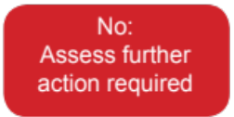
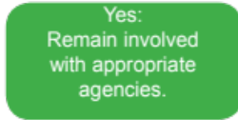
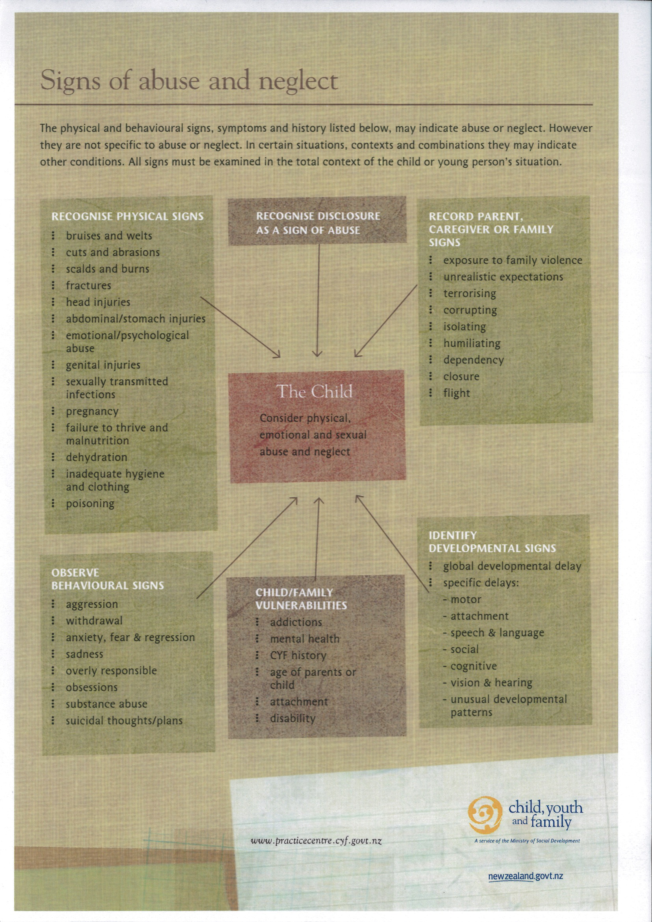
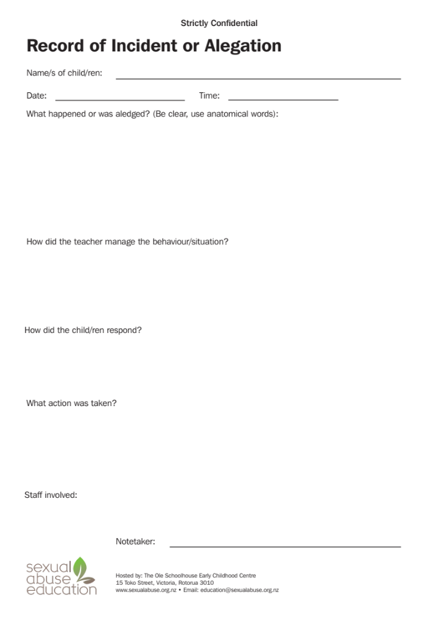

Describing injuries
Abrasion - a superficial scraping injury of the body surface with or without bleeding
Bruise - Leakage of blood from blood vessels discolouring the tissues of the body
Incision - A cutting type injury that severs tissues in a clean and generally regular fashion
Laceration - A tear or split in the tissues

In describing a wound consider the following features:

- Site
- Size
- Shape
- Surrounds
- Colour
- Contours
- Course
- Contents
- Age
- Borders
- Classification
- Depth

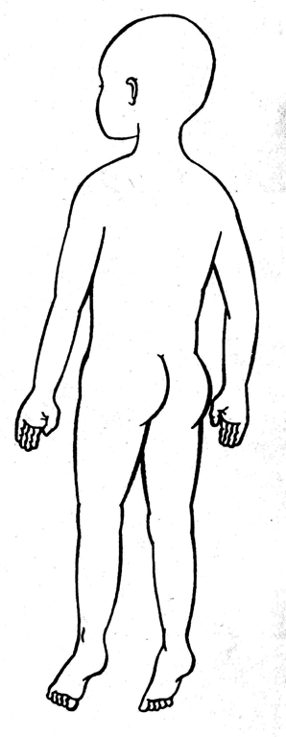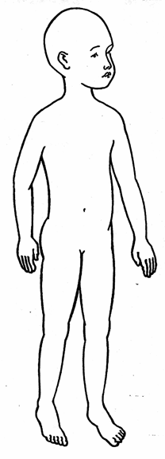
Child: Date: Time:
Teacher 1 Teacher 2:

Safety checking of all staff
The purpose of this operational procedure is to ensure appropriate compliance with
Licencing Criteria GMA7A. This policy also contributes to the Human Resource Management policies operated by this centre.
The purpose of this procedure is to ensure all staff working at our childcare centre meets the safety check requirements specified in the Children’s Act 2014. These measures are put in place to protect and improve the wellbeing of vulnerable children and strengthen our child protection system.
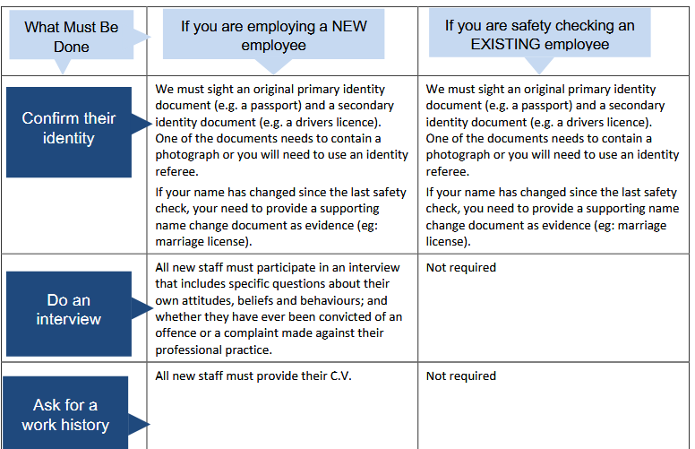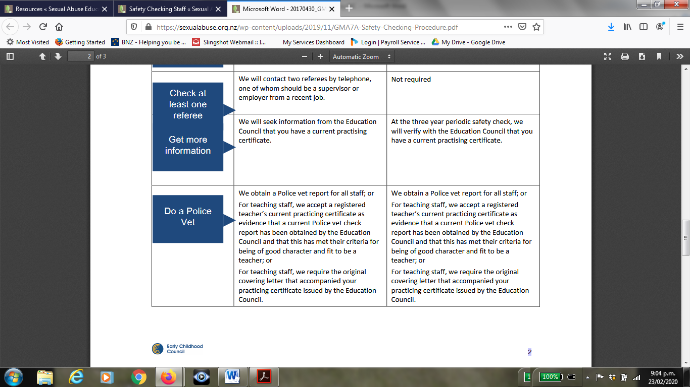

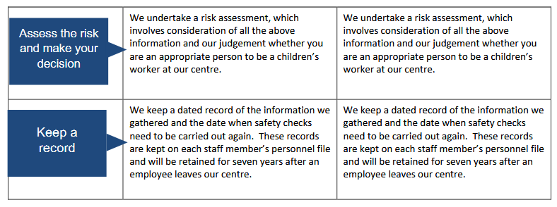

Questions to ask referees
Generic questions can cover:
  - Whether the referee considers the candidate suitable for the role and if not, why not.
  - Whether they consider the candidate suitable to work with children and if not, why not.
  - Details, including duties, position and job title, about the candidate’s employment.
  - Specific evidence that the referee can verify, about the candidate’s performance during employment.
  - The specific reason that the person left that role.
  - Details of any disciplinary procedures that resulted in formal action against a candidate.

Learning more about candidates
  - Details of any concerns relating to the safety and welfare of children, or the candidate’s behaviour towards children.8
  - Whether there were any sanctions relating to the safety and welfare of children, including whether or not such sanctions have expired.
  - Whether they would employ the candidate again.

Examples of specific questions:
  - Do you trust the candidate and if not, why not?
  - Have you ever had reason to suspect the candidate’s honesty?
  - Has the candidate ever mislead you?
  - Has the candidate ever been disciplined for misleading or fraudulent conduct?
  - How would you describe the way the candidate acts around children?
  - Was the candidate ever subject to formal disciplinary actions or complaints regarding their behaviour towards children?
  - Do you think the candidate should be unsupervised around children?
  - Was the candidate ever subject to formal disciplinary action or complaints regarding their disciplinary techniques?
  - How well do you think the candidate understands children?

Safety Check Interview Questions:
Interview questions for Full Safety Check
Children Act (2014)
This position is designated under the Children’s Act (2014) as being that of a ‘children’s worker’ role. As such we are obliged to safety check candidates for this position through a set process, which involves collecting evidence, including police vetting, in order to carry out a risk assessment.
Candidate name:
Information about the children’s worker themselves
- Whether complaints have ever been made about their professional practice and how they have responded to them.
- Whether they have ever been convicted of an offence.
- Whether they have ever been the subject of a complaints procedure during their employment.
- Reasons for leaving previous jobs.

Questions that explore the children’s worker’s attitudes
- Whether there has ever been a time when they have had to deal with the following situations, including the process and outcome. If that situation has not arisen, what they would do if:
  - A child or young person disclosed abuse.
  - They suspected a child was experiencing abuse.
  - A child or young person was cheeky or hit them.
  - They discovered children engaged in sexual play.
  - A child or young person invited them to become involved in intimate or touching behaviour.
Questions that indicate the children’s worker’s views on child safe practice
- How they believe children should be disciplined.
- Their thoughts on being alone on the job with children and young people.
- Is it acceptable for parents to smack children?
- Is time out effective?

Questions that describe the children’s worker’s experiences and relationships in working with children
- What rewarding experiences they have had working with children.
- What they think constitutes professional practice when working with children.
- The reason they think they get along with children or why children like them.
- The kind of relationships they hope to develop with the children and families in this organisation.

Additional Notes

Links to Other Policies
Examples of other policies to include requirements of this child protection policy are given here:
 | These policies…. | … should include the following details related to this Child Protection Policy:
1 | Personnel  Staff Safety Check policy | Ensure all new employees including relievers and students are screened with a VCA safety check. Repeat safety check every 3 years
2 | Sun Protection (Sunsmart) | Be visible to other adults when applying sunscreen.
3 | Sleeping Policy | Student teachers do not assist with sleeping unless accompanied by a full member of the teaching team. Relievers up to discretion of the Manager or Supervisor.
4 | Programme Assessment and Evaluation | Adequate supervision of staff and other adults when with children.  Adequate supervision of private spaces, e.g. toilet area, sleeping area, outdoor areas  Curriculum successfully teaches children about safe and unsafe touching, the names of body parts, how to say “no”, to tell a trusted adult as soon as possible, and about why some secrets are not good secrets to keep.  All adults working at the service are open about discussing good and poor practice.
5 | Excursions | Ensure more than one adult is on excursions and walks with children  Parent/ Guardian consent must be obtained.
6 | Complaints | Ensure complaints procedure is displayed  Include how parent and staff complaints can go forward to inform the Teacher’s Council (for example if an abuser is a registered teacher) and the Ministry of Education.
7 | Positive Guidance | Adults working at the service to model the appropriate behaviour, including safe touching (e.g. display of affection and empathy when a child is hurt).
8 | Appraisal | Establish staff roles and expectations of adult behaviour with children. Respectful to children as well as each other.  Keep professional and personal lives separate  Knowledgeable about the vulnerability of children and aware that it is not possible to know that an abuser is not already involved in the service.  Ask questions and challenge poor practice.
9 | Philosophy & Curriculum Policy | Provide opportunities for children to understand about personal safety and positive self-esteem.  All staff and others who assist at the service (including students on teaching practice) are supported to ask questions and challenge poor practice.

